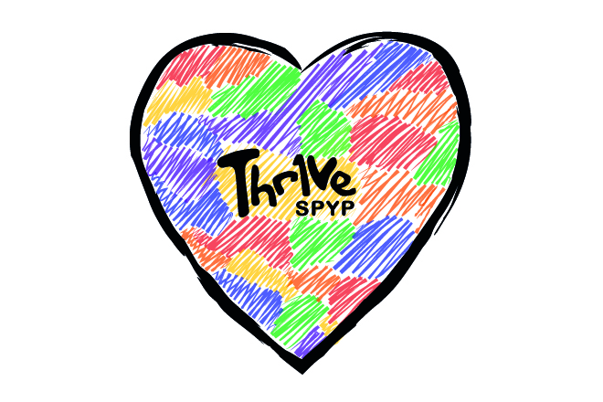

Youth Wellbeing Mentor – Person Specification
The following criteria outline the experience, skills and qualities required for the role.
Applicants should clearly demonstrate how they meet the essential criteria within the application pack.
Criteria | Essential | Desirable
Experience working in a supportive/mentoring role with young people | E
Experience working with young people from similar backgrounds to those accessing Thr1ve, e.g. anxiety, low confidence, social isolation, SEND, etc. | E
Experience of building and maintaining partnerships with external organisations. E.g. schools, GP practices, CAMHS, VCSE organisations etc. | E
Experience managing a caseload and working independently within a community-based setting. |  | D
Experience working within the voluntary and community sector |  | D
Level 3 qualification (or equivalent) in a relevant field, or demonstrate equivalent experience | E
Sound understanding of the social factors that impact young people’s wellbeing (e.g. isolation, housing, finances, family dynamics). | E
Strong IT skills and confidence using case management systems and email. | E
Ability to build rapport quickly in a relaxed, approachable way without judgement while maintaining professional boundaries. | E
Confidence networking across a wide range of partners to increase referrals and maintain professional relationships. | E
Ability to work flexibly, to meet the needs of young people and the service (including occasional evenings/weekends). | E
Full UK Driving Licence (required due to community-based delivery across North Derbyshire). | E
Knowledge of safeguarding, confidentiality, lone working and health & safety procedures. | E
Enhanced DBS clearance in line with legal requirements. | E
Thr1ve is committed to safer recruitment and promoting the welfare of children and young people.
All appointments are subject to satisfactory references and enhanced DBS clearance.

